**IELTS Writing Quiz**

**Writing Task 1**

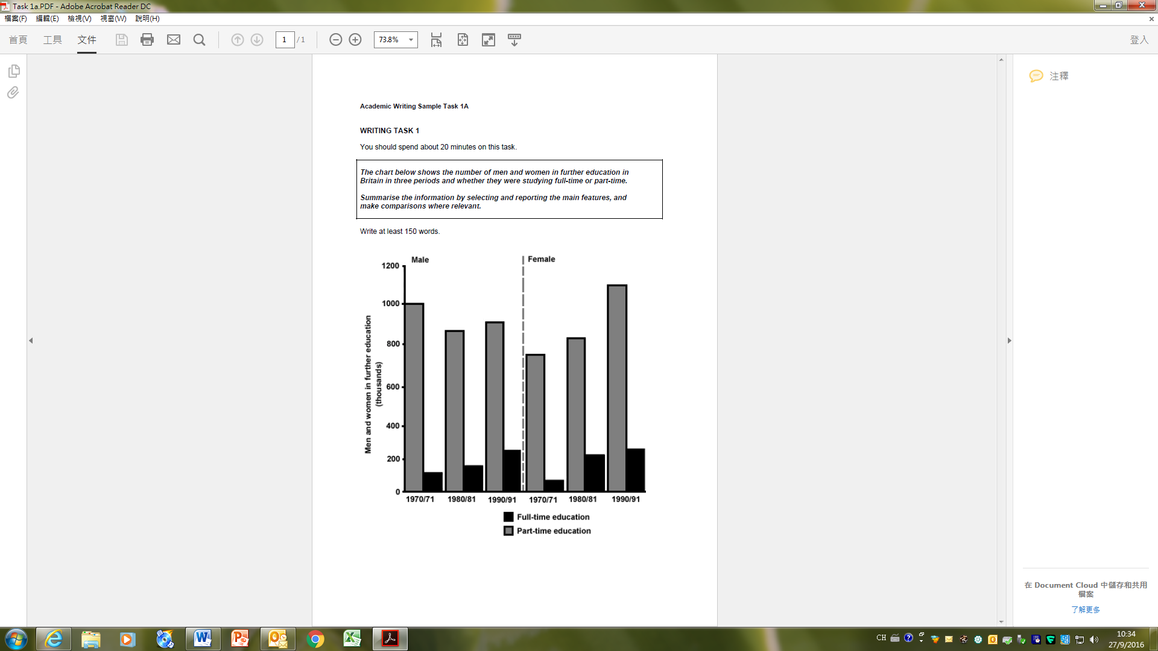

**Writing Task 2**

**You should spend 40 minutes on this task.**

|  |
| --- |
| Every year, international newspapers rank world cities according to their qualities. Such qualities may include affordable medical care, good education, a fair legal system, etc. List three qualities which you believe are most important, and give reasons for your choice. |